FireBot Water Leak Detection
Sales Program
Methods and Information
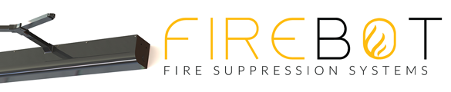
About FireBot
Based out of Springfield, Virginia, FireBot is quickly becoming the world leader in smart home safety devices, specializing in the two most important types of home protection: Water and Fire. While our flagship product is FireBot – Stove Top Fire Suppression System; in this document, we are focused on FireBot’s Water Leak Detection System.

Water Leak and Damage Mitigation Products
Water damage is a pervasive problem; based on insurance statistics, residential water damage affects around 14,000 people in the U.S. daily. According to the Insurance Institute, 1 in 60 insured homes yearly claim water or freeze damage. Make that one in 30 on those who repair the damages themselves. In any case, you get the job of repairing the leak, so you know firsthand the prevalence of water leaks. With FireBot Water Leak Sensors, a water leak activation will automatically close the water main before catastrophic damages occur while notifying the homeowner of a leak and its location via FireBot’s free app.

Earn an extra $150-$600 per call when you recommend the FireBot Family of products to your customers. How? Join FireBot’s all-new Dealer Program.
FireBot Water and Fire Products are designed to be the best in the world.
- 70% more effective than the rest of the market, proven through testing and feature comparison.
- 10 Year Battery Powered, no charging ever needed
- Omnidirectional Water Leak Detectors
- Strongest Water Valve Shutoff in the world; Installs over existing Water Valve
- LORA Wireless Technology For All Sensors
- Free App, Email, Text Alerts; Communicates to Multiple Contacts.
- Easy and affordable to install.

FireBot’s Water Sensor System is an affordable option for those wanting fast, reliable water detection that doesn’t break the bank.
When you recommend FireBot’s Water Sensors, you get to be the hero saving your customers from future water damage.
Add Revenue To Every Job, An Easy Process:

Dispatchers - It All Starts Here:
Upon hearing the words , “I have a leak”; Dispatchers be sure to mention the technician will come out to fix the leak and tell you about our incredible technology to detect and prevent future water leaks and the damage . Also, by installation, an insurance premium discount is possible based on your policy.

Service Call, To Solve A Problem In The Customer’s Home
The Plumber assesses the situation, Fixes the Leak, presents the FireBot brochure, and shows homeowners FireBot Water Leak System. Explains benefits, pricing, and has a form to write-up the order.

Sales/Installation Scenarios

Option 1. The Plumber facilitates the sale and Installs the system before leaving. The Plumber has inventory on the truck, installs devices immediately, and collects payment.

Option 2. The Plumber facilitates the sale but defers the installation. The Plumber calls the office and sets an appointment to return to install the system being sure to collect payment.

Option 3. Plumber sells Water Leak System and collects money for a “DIY Installation” by the Customer. Leaves kit behind with self-install instructions, online video instructions URL, and helpline number.

How Much Money Can You Make?

Note: You are a “Hero” for fixing the leak and preventing further damage.

Although not every customer, the think of all service calls to fix a plumbing leak. They have a high percentage and motivation to purchase an early warning system and a response system to stop further water damage. Let’s say you have 50 such calls a month. Can you place five units a month, ten units. Note that for every unit you place on average, you will profit $200-$600. That can average $4000-$6000 additional monthly profit, including labor. Plus, you get the benefit of your company labeled App, bringing future recurring business. See the pricing chart below.

Stocking Inventory
Inventory may be purchased to have several complete units on shelves back at the service center, one on each truck, or ordered separately by each sold job. Shipping charges apply.
Demo Kits are available ready to go in a backpack carry case.

INCREASE REVENUE PER CALL WITH THIS SIMPLE HI-TECH PRODUCT UPSELL

FireBot Water Sensors –
Sends wireless heartbeat signal every 6 hours; reporting temperature (to prevent freeze), low battery, and water detection. Upon activation, a notice is sent out with the location (multiple contact notifications capable), and a signal to turn off the water valve supplying water to the house. Omnidirectional detection or add a 10-foot remote

Five (5) Primary Water Leak Detector Locations:

• Leaky Water Heater/Boiler
• Sump Pump Failure
• Washing Machine Floor - Appliance leak
• Bathroom Floor – Under Sink or by Toilet
• Kitchen Floor – Under Sink or by Dishwasher

Benefits:

1. Prevents Property Damage: Prevent structural damage, mold growth, and damage to personal belongings.

2. Cost Savings: Saves money on water bills, costly repairs, and deductibles.

3. Peace of Mind: Especially when you're away from home.

4. Remote Monitoring: Via a smartphone app, check your home's water status in real time, from anywhere.

5. Water Conservation: You reduce water waste by identifying leaks and inefficiencies.

6. Insurance Discounts and lower premiums: As it reduces the risk of significant water damage claims and the hassle of managing costly contractors

7. Increased Home Value: A home equipped with a leak notification system may have a higher resale value and be more attractive to potential buyers.

Benefits Of Having Your Plumber Install Firebot Water Leak Detection

Having a plumber install a smart water leakage notification system offers several benefits, as we are trained professionals who can ensure the proper installation and functionality of the system.

1. Expertise: The necessary knowledge and experience to seamlessly install FireBot technology in the right locations.
2. Proper Placement: Plumbers can identify the best locations to install sensors and detectors for optimal leak detection coverage. They can also assess potential trouble spots and hidden leaks that homeowners might miss.

3. System Testing: After installation, plumbers can perform thorough testing to ensure FireBot Systems works correctly. This includes checking sensor responsiveness and connectivity to the monitoring platform.

4. Timely Response: In the event of a leak, a professional installation ensures you receive timely alerts on your smartphone or through a monitoring service. This can help you take swift action to minimize water damage.

5. Code Compliance: Plumbers are familiar with local plumbing codes and regulations, ensuring the installation complies with all necessary standards.

6. Reduced Liability: Professional installation can reduce the risk of installation-related issues that could void warranties or create liability concerns.

7. Long-Term Support: Plumbers can provide ongoing support and maintenance for your Plumbing PM - smart water leakage notification system, including troubleshooting and system updates.

ADDITIONAL REVENUE OPPORTUNITY WITH FIREBOT – STOVE TOP FIRE SUPPRESSION SYSTEM
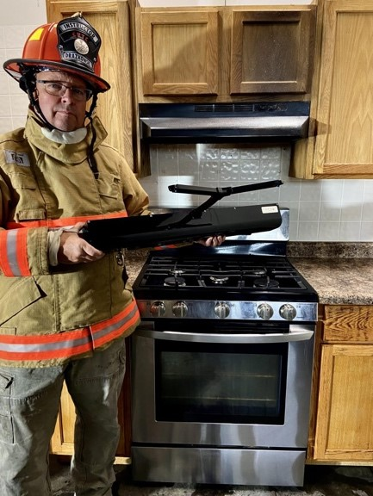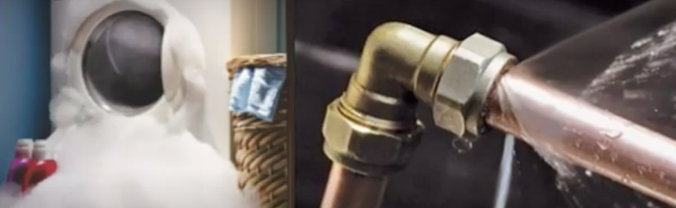

FireBot-Stops Stovetop Fires by over 50%, Over half start on stovetops.

AUTOMATIC FIRE DETECTION & SUPPRESSION
10-Year Battery
Wireless communication
One Liter Suppressant self-contained
The smart thermal sensors know the difference between everyday cooking and a fire it needs to suppress. FireBot will NOT activate from smoke, fire must be present.
When an out-of-control fire is detected a warning alarm will sound notifying everyone in the area of the situation.
FireBot will activate when there is an out-of-control fire that poses a risk to the building and its inhabitants.
Easy to Install
User Friendly
Self-contained system, no outside power or plumbing needed
Nontoxic suppressant.

Send a Mailer To Your Past Customers,
Print a date three weeks from your mailing date to create some urgency.
Add an Offer ending date, Phone Number website QR Code to find out more information.

Contact Information
Mark Baldino 703-906-3154 mark@firebotsuppression.com
FireBot Inc. 7400 Fullerton Rd Springfield VA 22153

