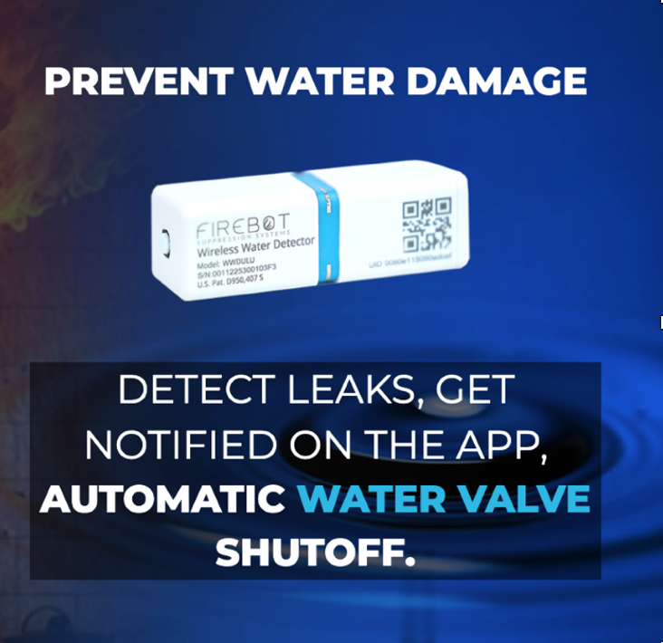

FireBot Products
Water Leak Detection/Mitigation

State Of The Art Risk Mitigation, To Serve Your Customers and Generate Profits

Protect your Customers! Water is the leading cause of damage in homes. Water damage can be prevented with our products, saving your Clients Tens of Thousands of dollars or even their homes. All while generating additional business for your company with smart technology.

FireBot adds additional revenue to the bottom line of your company. FireBot is also a product to bring your company into the electronic age; which homeowners, especially Smart Home, Homeowners are seeking.

FireBot Water Leak Program
Detect and Stop Water Leaks Early. Be a hero to your customers. Show you care, by protecting their home against expensive water damage repairs. Be the one to suggest they install a FireBot - Water Leak Detection System. A system with a ten (10) year battery life; an App to notify them on their cellphones of an activation and an ability to shut-off the Main Water Valve preventing catastrophic damage.

FireBot Water and Fire Products are designed to be the best in the world.

- 70% more effective than the rest of the market, proven through testing and feature comparison.
- Batteries last 10 Years Without The Need To Recharge
- Omnidirectional Water Leak Detectors
- Strongest Water Valve Shutoff in the world
- Installs on/over existing Water Valve
- LORA Wireless Technology For All Sensors
- Free App, Email, Text Alerts
- Easy and affordable to install.
- DIY - User-Friendly Product

FireBot Water Sensors

Detect Water on the Floor, Pipe Drips, Collection pans, and Sump Pump Levels.
Sends a wireless signal every 6 hours to check for a heartbeat, measures and reports temperature to prevent freeze, low battery, and water detection. Upon activation, a notice is sent out with the location, multiple contact notifications, and a signal to turn off the water valve supplying water to the house. With its compact sub-lipstick size, you can deploy our sensors in any location prone to water leaks. Its special design makes it incredibly easy to fit into any corner or edge. Plus, it has an impressive battery life of one decade, so you can rest assured that it will provide you with reliable protection for years to come.

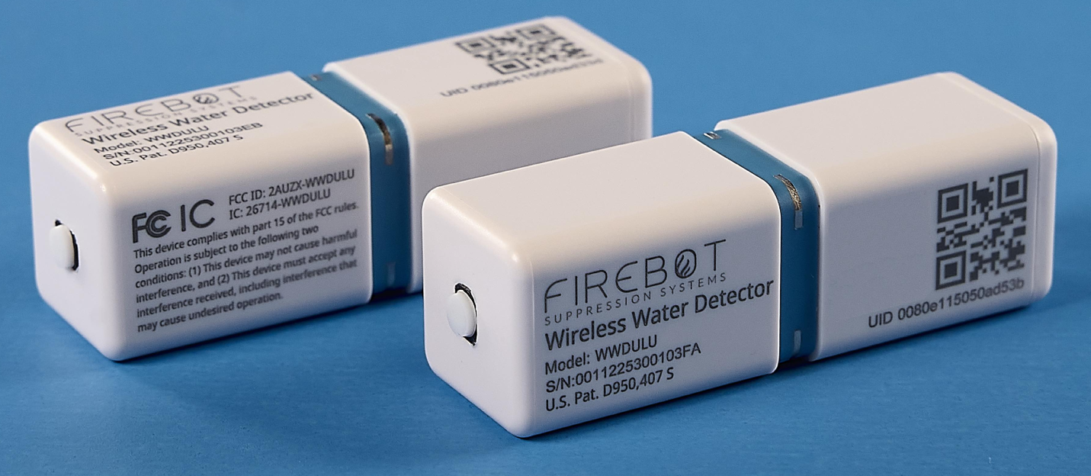

Additional Options Omnidirectional Detection or add a 10-foot remote.

LoRa WAN Gateway

No matter the size of the house, there is always communication coverage
Low power consumption, Stability, and more.

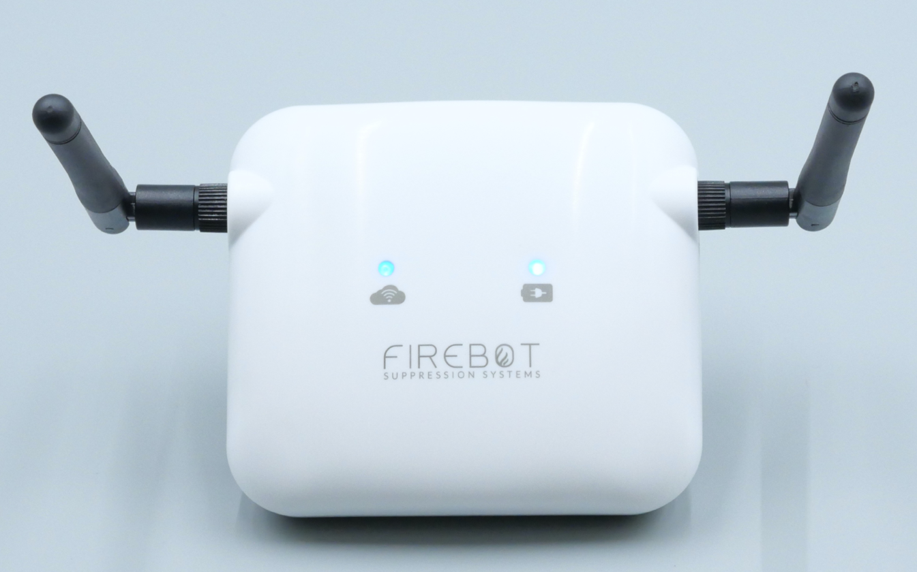

Main Water Valve Shut-Off

Once the water sensor detects a leak, the Main Water Flow Valve is closed automatically preventing a larger leak and damage to property.
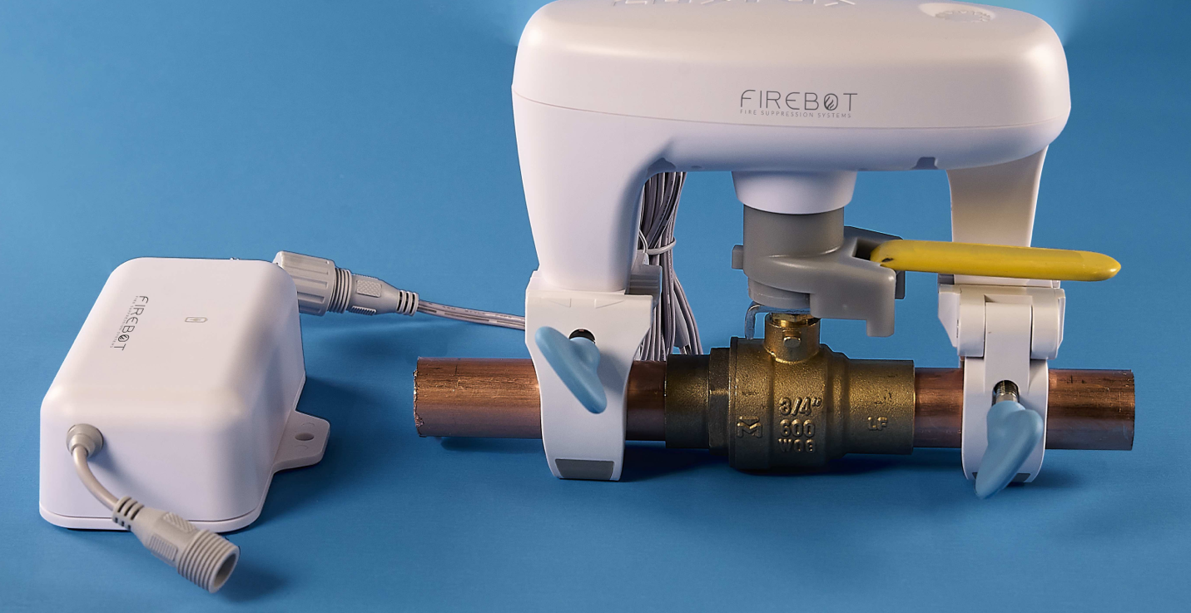

User-Friendly Smartphone App

Get instant notifications when a water event occurs anywhere in the
world. Administrate your entire network from your phone.
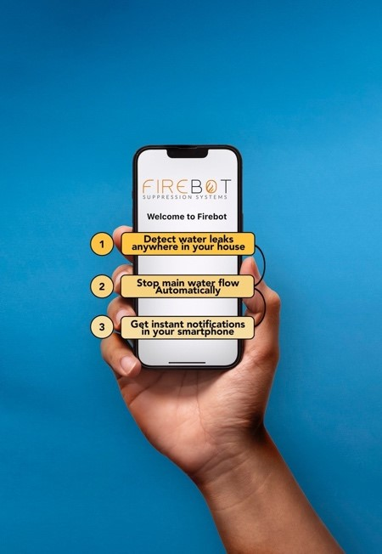
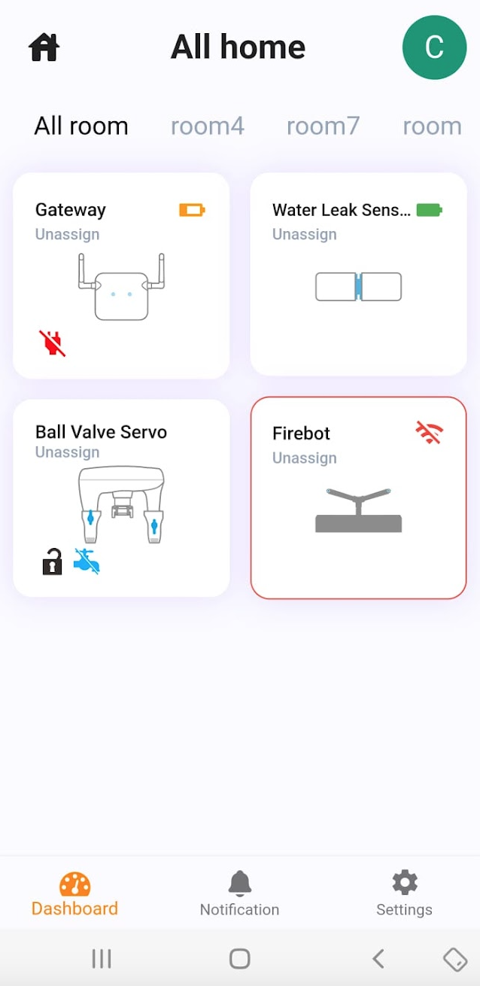

Stop Residential Water Damage

A system to protect your whole house, rental properties, and managed multifamily.
With FireBot, you can have complete peace of mind knowing that your property is safe from Water Damage. Our solution offers unparalleled reliability and security, making it the best choice for anyone looking to protect their home or business. So why wait? Safeguard your property from water damage, no matter what.

Contact Information
Mark Baldino 703-906-3154 mark@firebotsuppression.com
FireBot Inc. 7400 Fullerton Rd Springfield VA 22153
